LAB 1

Q1. Learn some basic concepts of oops using java.

class Basic{

    public static void main(String a[])

    {

        // System.out.print(6);

        System.out.println(6);

        System.out.println(7);

        int num1=2;

        int num2=3;

        int sum = num1+num2;

        System.out.println(sum);

        int mul = num1*num2;

        int div = num1/num2;

        int sub = num1-num2;

        System.out.println(mul);

        System.out.println(div);

        System.out.println(sub);

        if(sum>=6){

            System.out.println("greter");

        }

        else{

        System.out.println("Smaller");}

        double num5=5.6;

        float num6=5.6f;  //This is explicit typecast because double is default datatype for decimal

        System.out.println(num5);

        System.out.println(num6);

        short sh=558;

        long l=5854; // this is running because my jdk is above 17 and if my jdk is 17 then it will give error then we have to typecast it into l

        System.out.println(sh);

        System.out.println(l);

        byte b=127;

        int c=12;

        System.out.println(c==b);

        c=b;

        b=(byte)c; // this  is giving error because byte takes 1 byte and int takes 4bytes

        // System.out.println();

        int flag=5;

        System.out.println(b);

        while(flag>0)

        {

            System.out.println("Success");

            flag--;

        }

        do {

            System.out.println("Success "+flag);

            flag++;

        } while (flag<6);

    }

}

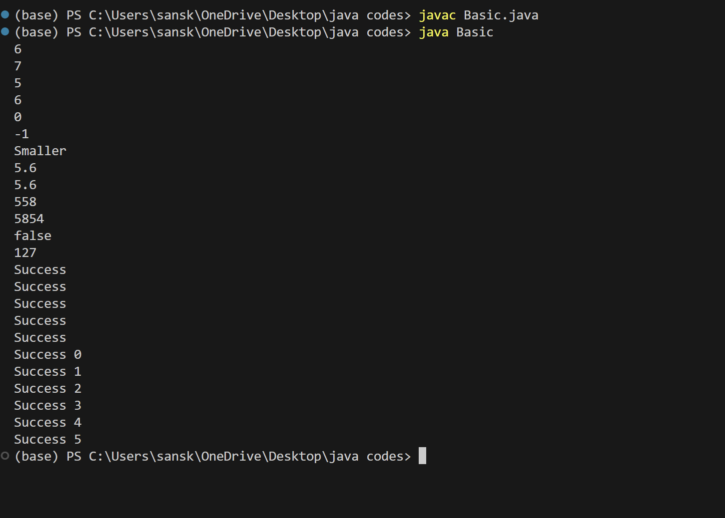**Output :**

Q2. Now apply these basic concepts and make a class which contains the details of smartphone

public class Lab1 {

    String Brand;

    static String product;

    int price;

    public void show()

    {

        System.out.println(Brand + " "+ product +" " +price);

    }

    public static void main(String a[])

    {

        Lab1.product="Smartphone";

        Lab1 obj1=new Lab1();

        obj1.price=50000;

        obj1.Brand="Samsung";

        obj1.show();

        Lab1 obj2=new Lab1();

        obj2.price=60000;

        obj2.Brand="Samsung";

        obj2.show();

    }

}

**Output :**

